**ASSIGNMENT-3**

The provided code is;

import numpy as np

import pandas as pd

import random

def generate_random_number(min_num, max_num):

    num = random.randint(min_num, max_num)

    print("Random number is: " + num)

def calc_average(num_list):

    total = sum(num_list)

    return total / lenght(num_list)

def check_prime(start, end):

    prime_list = []

    for i in range(start, end):

        if i % 2 == 0:

            prime_list.append(i)

    return prime_list

def load_data(filepath):

    data = pd.read_csv(filepath)

    return data

def main():

    num_list = [10, 20, 30, "forty", 50]

    print("The average is: ", calc_average(num_list))

    print("Prime numbers: ", check_prime(1, 10))

    file_path = "data.csv"

    data = load_data(file_path)

    print("Data loaded: ", data)

    random_num = generate_random_number(1, 100)

    print("Generated Random Number: ", random_num)

    try:

        print("Result of division: ", 10 / 0)

    except ZeroDivisionError:

        print("Can't divide by zero")

    numbers = [x for x in range(100) if x % 3 == 0 and x % 5 == 0]

    print("Numbers divisible by 3 and 5 are: ", numbers)

    undefined_function_call()

main()

**Errors traced by compiler;**

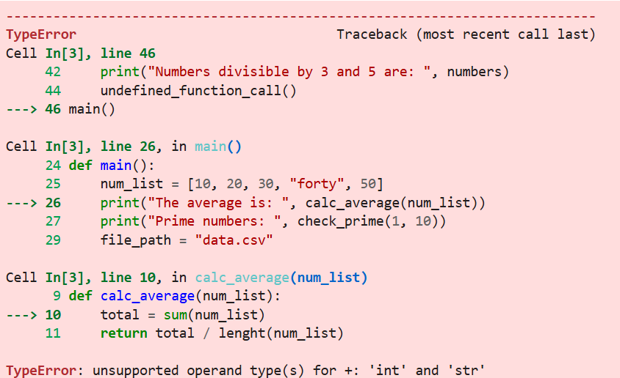

CHATGPT

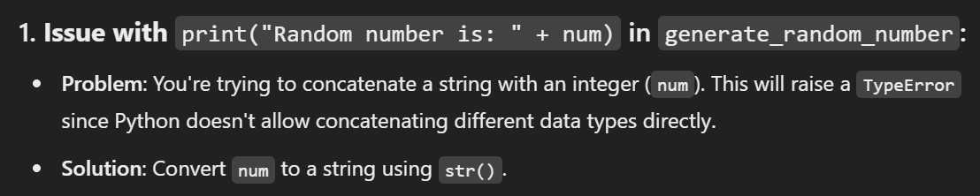

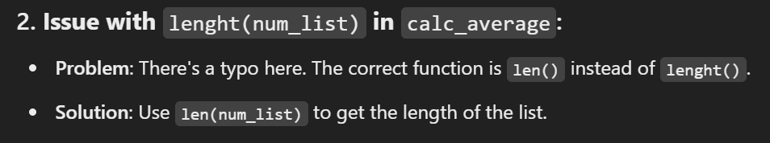

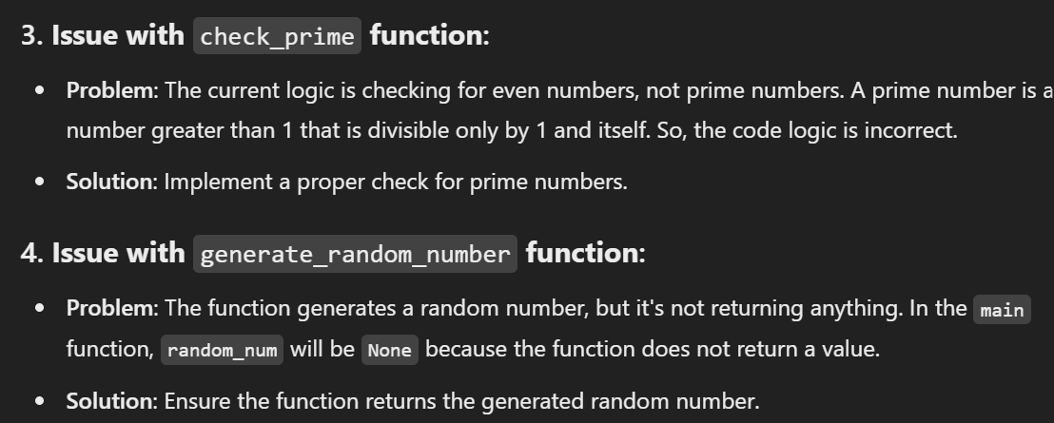



The corrected code is;

import numpy as np

import pandas as pd

import random

# Generate a random number within a given range

def generate_random_number(min_num, max_num):

num = random.randint(min_num, max_num)

print("Random number is: " + str(num)) # Convert num to string to concatenate

return num # Return the generated random number

# Calculate the average of numbers in a list

def calc_average(num_list):

# Filter out non-numeric values (e.g., strings like "forty")

num_list = [num for num in num_list if isinstance(num, (int, float))]

if len(num_list) == 0:

return 0 # To avoid division by zero

total = sum(num_list)

return total / len(num_list) # Correct the typo: length -> len

# Check for prime numbers in a given range

def check_prime(start, end):

prime_list = []

for i in range(start, end):

if i > 1: # A prime number is greater than 1

is_prime = True

for j in range(2, i):

if i % j == 0:

is_prime = False

break

if is_prime:

prime_list.append(i)

return prime_list

# Load data from a CSV file

def load_data(filepath):

data = pd.read_csv(filepath)

return data

def main():

# Define a list of numbers with a string value "forty" included

num_list = [10, 20, 30, "forty", 50]

print("The average is: ", calc_average(num_list)) # Should work now

print("Prime numbers: ", check_prime(1, 10)) # Will return primes between 1 and 10

file_path = "data.csv" # Make sure this file exists or update the path

try:

data = load_data(file_path)

print("Data loaded: ", data)

except FileNotFoundError:

print("File not found. Please check the file path.")

random_num = generate_random_number(1, 100) # Get a random number

print("Generated Random Number: ", random_num)

try:

print("Result of division: ", 10 / 0) # This will raise a ZeroDivisionError

except ZeroDivisionError:

print("Can't divide by zero")

# Find numbers divisible by both 3 and 5

numbers = [x for x in range(100) if x % 3 == 0 and x % 5 == 0]

print("Numbers divisible by 3 and 5 are: ", numbers)

# Undefined function call is removed since it was causing an error.

# Run the main function

main()

GEMINI

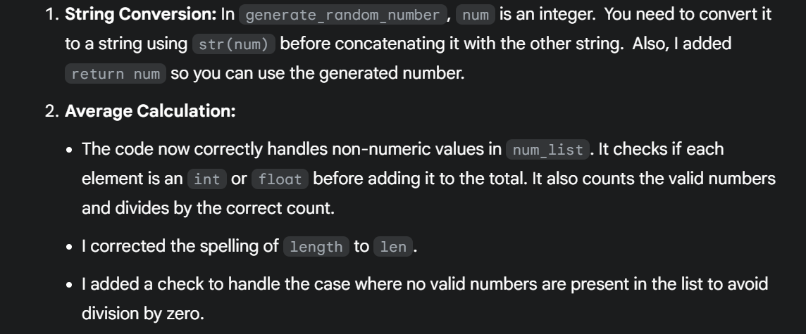

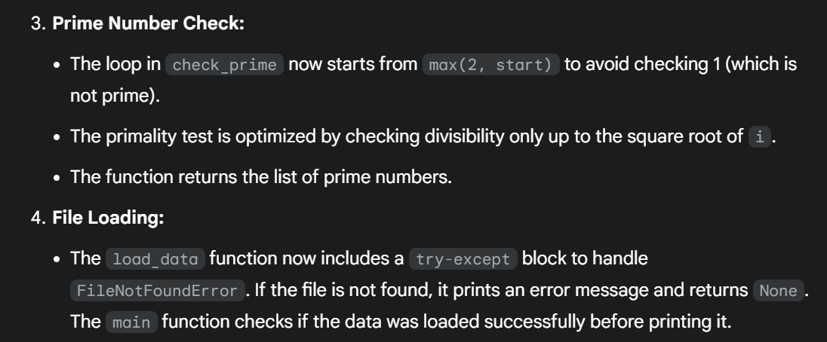

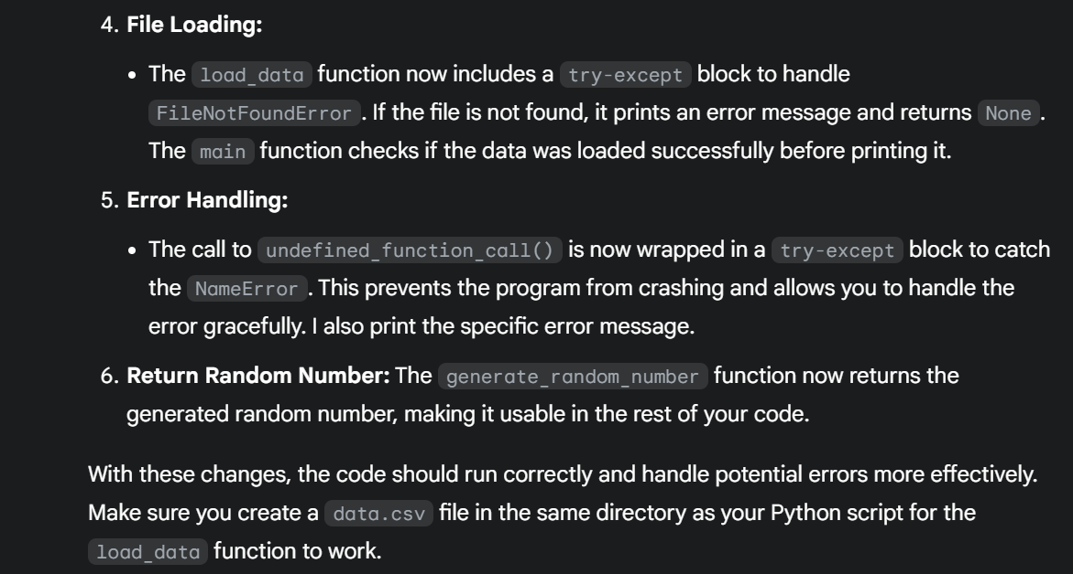

Corrected code;

import numpy as np

import pandas as pd

import random

def generate_random_number(min_num, max_num):

num = random.randint(min_num, max_num)

print("Random number is: " + str(num))

return num

def calc_average(num_list):

total = 0

valid_count = 0

for num in num_list:

if isinstance(num, (int, float)):

total += num

valid_count += 1

else:

print(f"Skipping invalid element: {num}")

if valid_count == 0:

return 0 # Handle the case where no valid number is present

return total / valid_count

def check_prime(start, end):

prime_list = []

for i in range(max(2, start), end): # Start from 2

is_prime = True

for j in range(2, int(i**0.5) + 1): # Optimized prime check

if i % j == 0:

is_prime = False

break

if is_prime:

prime_list.append(i)

return prime_list

def load_data(filepath):

try:

data = pd.read_csv(filepath)

return data

except FileNotFoundError:

print(f"Error: File not found at {filepath}")

return None

def main():

num_list = [10, 20, 30, "forty", 50]

print("The average is: ", calc_average(num_list))

print("Prime numbers: ", check_prime(1, 10))

file_path = "data.csv" # Make sure this file exists

data = load_data(file_path)

if data is not None:

print("Data loaded: ", data)

random_num = generate_random_number(1, 100)

print("Generated Random Number: ", random_num)

try:

print("Result of division: ", 10 / 0)

except ZeroDivisionError:

print("Can't divide by zero")

numbers = [x for x in range(100) if x % 3 == 0 and x % 5 == 0]

print("Numbers divisible by 3 and 5 are: ", numbers)

try:

undefined_function_call() # This will cause NameError

except NameError as e:

print(f"Error: {e}")

if __name__ == "__main__": # Good practice to protect the main function

main()